In production

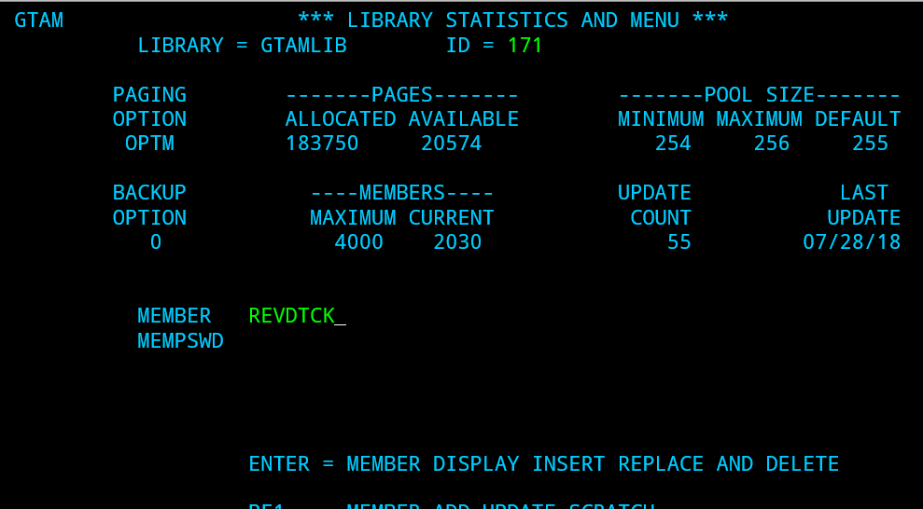

Use F8 to do page down to reach to our expected rev date.

Here, it’s shown as highlighted in the format (LOB) (STATE)(SYMBOL), i.e., HP 13TH

